**Rossmoyne Senior High School Physics Unit 3 and 4 2021**

**Period Zero Test 2: Electromagnetism SOLUTIONS**

**Name: __________________________________ Score: _________ /44**

**Time:** 45 min + 5 min reading

**Materials Provided:** This Question/Answer Booklet and the Formulae and Data Booklet

**Instructions:** When calculating numerical answers, show your working or reasoning clearly and include appropriate units. Give final answers to **three** significant figures. When estimating numerical answers, give final answers to a maximum of **two** significant figures.

1. Two parallel wires A and B carry a DC current in opposite directions as shown below.
   1. On the diagram below, sketch the following:
      1. the combined magneticfield surrounding the two wires. (2)
      2. the direction of the force acting on **each** of the wires. Clearly label these forces with an “F”. (1)

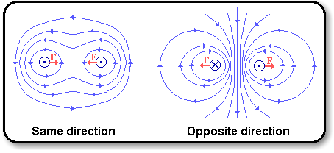

1 Mark direction of circular shape around each wire

1 mark for denser field in middle

1 Mark direction of forces

* 1. Wire A carries a 2.50 A current and wire B is placed 3.20 cm from wire A. Calculate the magnetic flux density at wire B, caused by the current in wire A. (2)

$B=\frac{μ_{0}}{2π}*\frac{I}{r}$

$B=\frac{4π*{10}^{-7}}{2π}*\frac{2.50}{0.032}$ 1 mark for concept

1 mark

* 1. Wire B carries a 1.20 A current. Calculate the force **per** **centimetre** applied to wire B. Include units. (3)

$F=IlB$

$\frac{F}{l}=IB$

$\frac{F}{l}=1.20*1.56*{10}^{-5}$ 1 mark for concept. Also allow setting $l=0.01 m$

$\frac{F}{l}=1.87*{10}^{-7} N{ cm}^{-1} away from wire A$ 1 mark value, 1 mark unit

1. A conductor XY is made to fall between the poles of a magnet as shown below such that it cuts lines of magnetic flux.
   1. On the external circuit drawn, indicatethedirection of the induced current. (1)

X

**N Flux Lines**

**S**

Y

Motion of the conductor

I

Direction of current. 1 mark.

* 1. The conductor XY is 20.0 cm long and is completely within the external 8.00 T magnetic field. Calculate the speed of the conductor if the voltmeter in the external circuit measures 7.20 V. (2)

$emf=lvB$

$v=\frac{emf}{lB}$ 1 mark for concept

$v=\frac{7.20}{0.20*8.00}$

$v=4.50 m{ s}^{-1}$ 1 mark

1. A metal roller of mass 3.00 kg accelerates along a pair of conducting tracks due to the applied emf and magnetic field as in the diagram below. The two tracks are held firmly in place.
2. On the diagram clearly show with an arrow the direction the roller is accelerating in. (1)

Arrow clearly drawn to left, no other ambiguity (extra unlabelled arrows). 1 mark.

1. Calculate how wide the track is given a current of 6.00 A flows, the magnetic flux density is 2.00 T and the roller accelerates at 6.40 m s-2. (3)

Find force acting on conductor. F = ma = 3.00 x 6.40 1 mark for concept

F = 19.2 N

Find length of the conductor. F = IlB

$l=\frac{F}{IB}=\frac{19.2}{6.00*2.00}$ 1 mark for concept

$l=1.60 m$ 1 mark

1. The following diagram represents the main parts of a simple electric motor.
2. **Label the parts** represented by 1, 2, and 3. (3)

**3. Coil/**

**Armature**

**B**

**C**

**S Flux Lines**

**N**

**2. Split ring commutator/ Commutator**

# A

**D**

**1. Carbon brushes**

**X**

**Y**

1 mark each

**DC Power source**

1. What is the **polarity of X** (positive or negative) if the current causes side AB of the coil to move downwards? (1)

Positive 1 mark

1. How much torque does the 80 turns motor produce in the position shown in the diagram if the current flowing in the coil is 2.50 A, the magnetic flux density between the magnets is 825 mT, the length BC is 18.0 cm and the length CD is 27.0 cm. Give your answer to a suitable number of significant figures. (3)

Force on each side:

$F=NIlB=80*2.50*0.27*0.825=44.55 N$ 1 mark for concept

Total torque:

$τ=2Fr=2*44.55*\frac{0.18}{2}$ 1 mark for concept

$τ=8.02 Nm$ 1 mark (to 3 sig figs)

**OR**

$τ=NIAB$

$τ=80*2.50*\left(0.27*0.18\right)*0.825$ 2 marks. -1 Each mistake in numbers/conversions.

$τ=8.02 Nm$ 1 mark (to 3 sig figs)

1. A negatively charged oil drop in a vacuum is suspended between two parallel plates. The oil drop is suspended because an electric force balances the weight force. The plates have a potential difference across them because of an applied emf. The equipment is set up as shown below.

15.0 cm

Oil Drop

* 1. On the diagram, draw the electric field **produced by the oil drop** (ignore the plates). (1)

At least 4 arrows, radial towards the centre of the drop. 1 mark

* 1. The mass of the oil drop is 1.86×10-5 kg and its charge is 1.30×10-5 C. Calculate the electric field strength produced by the parallel plates required to suspend the oil drop between the two parallel plates. (3)

$Weight force=Electric force$

$mg=qE ∴ E=\frac{mg}{q}$ 1 mark for concept

$E=\frac{1.86*{10}^{-5}*9.8}{1..30*{10}^{-5}}$ 1 for correct rearrangement and numbers

1 mark

* 1. What is the magnitude of the potential difference between the plates that creates the electric field calculated in part (b). (2)

$E=\frac{V}{d} ∴V=Ed$ 1 mark for concept

$V=14.0*0.15=2.10 V$ 1 mark

1. A long, straight wire carrying 3.60 A creates a magnetic field surrounding the wire. A positively charged particle comes into close proximity of the wire, moving initially in the same direction as the current. The particle performs non-uniform loops restricted to within the plane of the page **(**the diagram below is **not** 3D**)**.

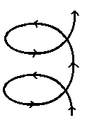

$$I$$

$$q$$

Non-uniform loops:

* small radius near wire
* large radius far from wire
  1. Draw the magnetic field produced by the current in the wire that would exist inside the box to the left of the wire. There is no need to draw any magnetic fields that may exist outside of this box. (1)

Draws field out of page in box provided (1)

* 1. Calculate the magnetic flux density 20.0 cm from the wire. (2)

1

1

* 1. Explain why the charged particle is deflected as it passes by the wire and explain why the radii of the loops are smaller when the particle is closer to the wire. (5)

States the deflection is due to magnetic forces acting on charge 1

Elaborates on direction of force (right hand rule/directions in diagram) 1

States the flux/field is denser/stronger near the wire 1

States the radius decreases with larger (centripetal) force ($F_{c}=\frac{mv^{2}}{r}$), referring to formula 1-2 1

**OR**

States the radius of curvature decreases with increasing magnetic flux density, including reference to $r=\frac{mv}{Bq}$

1-2

1. 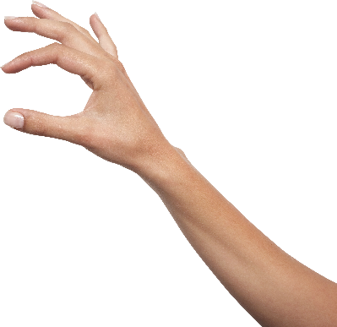Two biologists were studying the ability for tortoises to right themselves when they are lying upside down. A physicist was called in to help with making a simplified model of an upside down tortoise.

$$F$$

36.0 cm

15.0 cm

10.0 cm

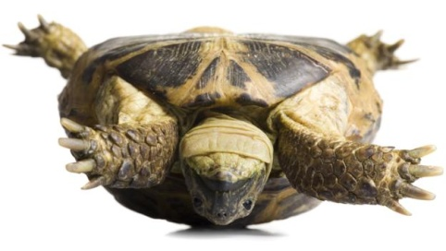

* 1. Assuming the tortoise has a uniform density, estimate the magnitude of the force labelled $F$ in the diagram required to start flipping the tortoise over onto its side. Give your answer to a suitable number of significant figures. [5 marks]

Make the pivot point the edge of the shell in contact with the ground.

Find the force where the torque produced by the weight of the tortoise only just balances with F.

Estimate the tortoise to have a 10 kg mass. 1, estimate between 1 and 20 kg

$\sum{τ_{cw}}=\sum{τ_{acw}}$

$torque of F=torque of weight$

$Fr=F_{w}r_{w}$ 1

$F*0.15=10*9.8*0.05$ 1-2

$F=33 N$ 1, max 2 sig figs

* 1. Once the tortoise is the right way up, the simplified model of the tortoise looks like the diagram below.

$$F$$

Explain, using physics principles, whether the tortoise is more stable when upside down or right way up. (3)

Describes conditions for stability/instability 1

“To tip the tortoise requires an unbalanced torque, where torque produced by F > torque produced by weight.”

Describes differences in distances that affect torque 1

“The torque produced by weight is greater when the right way up because the distance from the edge to the weight is greater.”

Relates back to question 1

“This would require a greater F to tip the tortoise, thus it is more stable when the right way up.”

**END OF TEST**